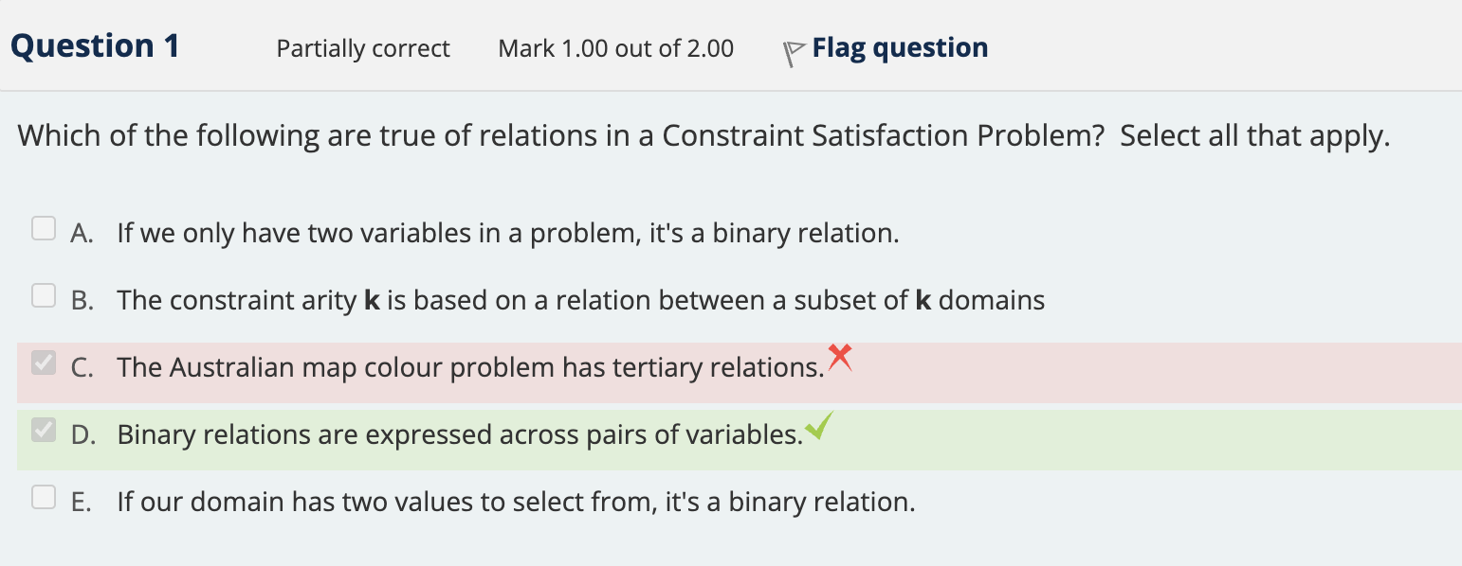

正确答案B，D

A不对因为This is not necessarily true. Having only two variables in a problem does not mean that the relation between them is binary. There could be a unary relation for each variable or a higher arity relation that involves more variables.

B对：Constraint arity 代表一个constraint里有多少个variable，然后因为题目描述的是a relation between acsub set of k domains， 因为是一个关系，所以一个关系里的variable数量自然与constraint arity相等

C：不对因为澳大利亚那个题目里面的关系是两个相邻地区的颜色是否相等，则这是一个binary relation

E：不对因为This is false. The number of values in the domain does not determine the arity of the relation. The arity is determined by the number of variables involved in the constraint, not the size of the domain.

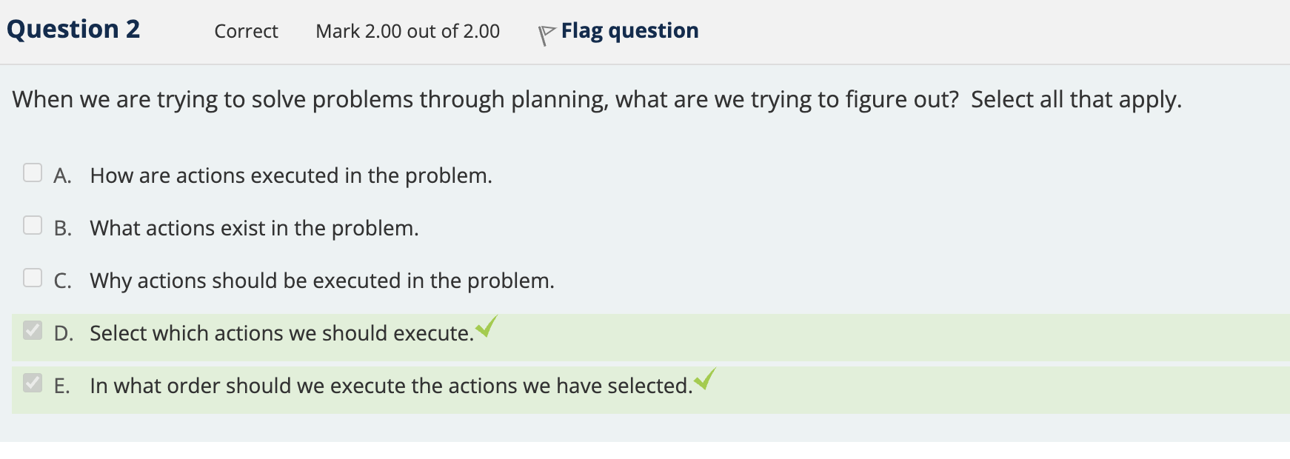

A不对因为how action execute不由planning 管，这是系统考虑的东西

B不对因为what actions exist 是最开始就要在domain里提供的条件

C不对因为why actions should be executed不是planning主要在乎的方向，planning更注重于怎么达到，期间经过哪

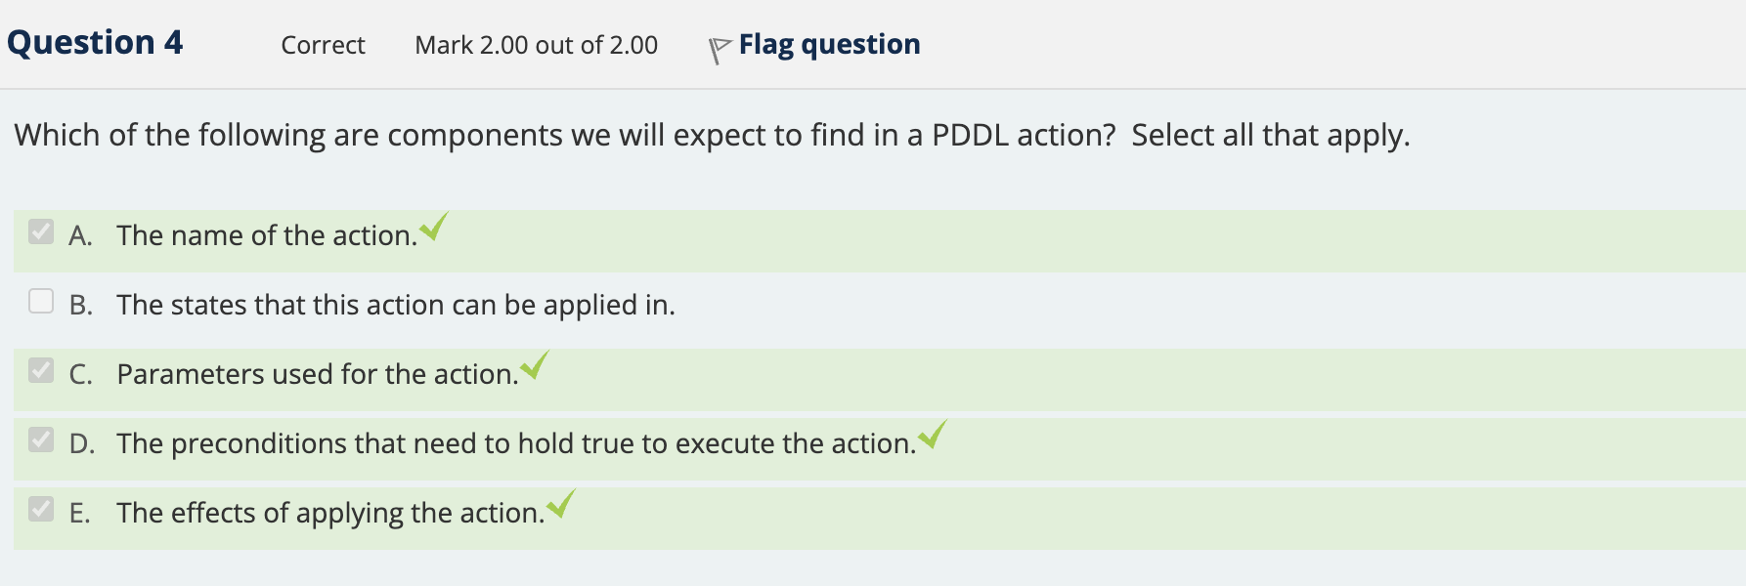

A. The name of the action.

* Correct: A PDDL action needs a name to be uniquely identified and referred to within the domain.

B. The states that this action can be applied in.

* Incorrect: In PDDL, we do not explicitly specify the states in which an action can be applied. Instead, we use preconditions to determine the conditions that must be satisfied for the action to be executable.

C. Parameters used for the action.

* Correct: PDDL actions often require parameters that represent the objects involved in the action. These parameters are used to instantiate actions with specific objects from the problem.

D. The preconditions that need to hold true to execute the action.

* Correct: Preconditions define the conditions that must be satisfied in the current state for the action to be executable. These conditions must be met before an action can be applied.

E. The effects of applying the action.

* Correct: The effects of an action describe how the state changes when the action is executed. They specify which predicates are added or removed from the current state upon the successful execution of the action.

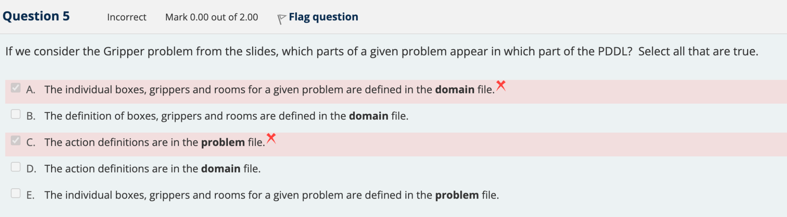

A不对因为这些东西是在problem file里要注明的东西，比如说这个问题包含了啥东西，要干啥

B对因为需要知道每个东西的detail

C不对因为action definition也要在domain里注明

D对原因如c

E如a

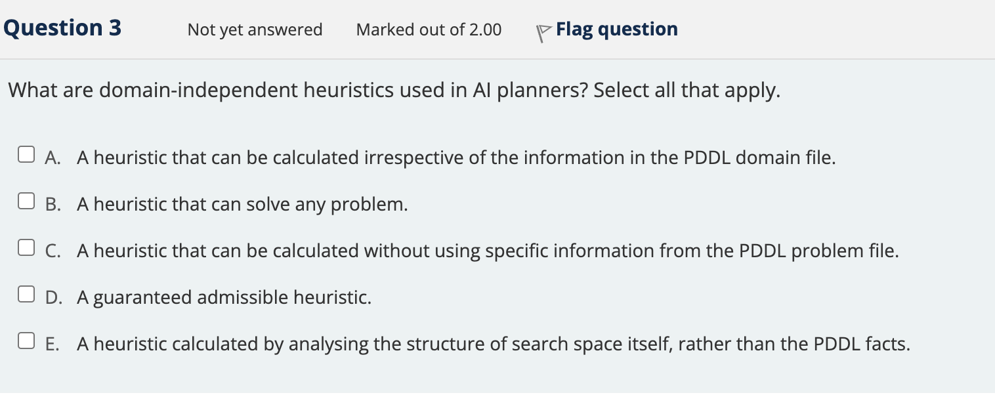

Domain-independent heuristics in AI planners are used to guide the search for a solution in a general way, without relying on specific information from the given domain or problem. Here's a detailed explanation for each option:

A. A heuristic that can be calculated irrespective of the information in the PDDL domain file.

This means that the heuristic does not rely on the specific structure or content of the domain file. It can be applied to any valid PDDL domain, making it more versatile across different planning problems.

B. A heuristic that can solve any problem.

This option is not correct. A heuristic does not guarantee a solution to any problem; it only guides the search process towards an optimal or near-optimal solution. The success of a planner depends on the algorithm and the specific problem being tackled.

C. A heuristic that can be calculated without using specific information from the PDDL problem file.

Similar to option A, the heuristic does not depend on the specific details of the problem file. This enables the heuristic to be used for different problems within the same domain or even across multiple domains.

D. A guaranteed admissible heuristic.

This option is not necessarily true for all domain-independent heuristics. An admissible heuristic is one that never overestimates the cost to reach the goal. While some domain-independent heuristics might be admissible, it is not a requirement for all domain-independent heuristics.

E. A heuristic calculated by analyzing the structure of the search space itself, rather than the PDDL facts.

This is true for some domain-independent heuristics. These heuristics focus on the search space's properties rather than the specific PDDL facts. This allows the heuristic to be more general and applicable across different domains and problems.

So, the correct options are A, C, and E.

